MATLAB Simulation Function Suite

Introduction
The algorithms that have been previously detailed for the forward and inverse kinematics of the NUWAR robot were implemented in MATLAB. This served as a check for their validity and also gave a graphic interpretation of the robot's movement.
Also implemented were several trajectory generation schemes which call the kinematics functions. These can output a time history of motor angles required to achieve the desired trajectory. This could then be entered into a PMAC motion program in SPLINE mode to program the motors to follow the desired path.
This section illustrates the set-up of the functions by displaying flow charts which show how they are related (ie: what calls what). It is hoped that this will result in easier code interpretation. The code itself has been well commented, and uses the same variable names as presented in the sections on the forward and inverse kinematics.
MATLAB was selected because it facilitates the use of vectors and matrices, making robotic simulations easy to implement. There is also the advantage that the functions take up less code than say in C, where the programming environment is more formal. Also, MATLAB simplified the creation of a solid graphical representation of the robot as it automatically deals with the 3-D viewing transformations and depth sorting etc.

Categories of Functions

Geometric Initialisation Function
- Initarms

Matrix Functions
- Trans | - Rotz
- Rotx | - DHtrans
- Roty | - Invht

Kinematic Functions
- IK
- FK
- FK2

Trajectory Functions
- Ellipt3p | - PolyTime
- Rapid | - SineOnRamp
- Cycloid | - Bezier
- Animationikbezier | - Ellipt2p
- Natural

Plotting Functions
- Plotframe | - Xcylinder
- Initbase | - Zcylinder
- Initialisedisplay | - Revolve
- Transsurf | - Plotspace

Animation Functions (for demonstrating the kinematic functions)
- Animationfk1
- Animationfk2
- Animationik1

Major Parameters
The geometric parameters for the NUWAR robot are set in the function "Initarms" where the length of both the control arms and forearms are set as well as the size of the gripper plate and base plate. The width between the parallel rods of the forearms can also be set here for accurate rendered cylinder representations of the robot. To edit these parameters, type "edit initarms" at the MATLAB prompt. The current settings correspond to those of the mechanical design for the NUWAR robot. Refer to [Shane98] and [Roberts98] for comparison.
The "drawmode" parameter is common to most of the functions written. It is used to specify various preferences relating to the graphical output of these functions. The "drawmode" is specified as a function argument using a 1 by 6 vector containing six different preferences. A summary of these preferences is given below:
1st preference - specified in the range from 0 to 3.
0 - don't produce any graphical output (don't draw the robot)
1 - draw a simple wire frame representation of the robot
2 - draw a wire frame model with more accurate forearms
3 - draw a rendered cylinder representation of the motors and robot.
2nd preference - specified as either 0 or 1
0 - don't draw any coordinate frames
1 - draw the coordinate axes corresponding to the base and motors
3rd preference - specified as either 0 or 1
0 - don't initialise the screen at all
1 - initialise the screen and draw the base and motors
The purpose of this preference is to allow the base and motors (everything that remains stationary) to be drawn just once, such that only the moving parts are updated. This feature is used in the animation functions. This parameter can then be set to 0 after the base has been drawn, such that subsequent calls to "IK" to not result in the base being re-drawn.

4th preference - specified as either 0 or 1
0 - create a new figure to draw to
1 - draw to the GUI, "nuwargui"
This parameter is used for internal purposes to call the various functions from within the GUI ( "nuwargui"), and to allow the functions to also be run from the MATLAB command prompt.

5th preference - number of plots
This preference can be used to set up a stereo image when equal to 2, or different views of the same pose or movement when equal to 4.

6th preference - specified as either 0 or 1
0 - do not create a movie for playback
1 - create a movie for playback
The animations run slower when a movie is being produced. Once produced however, movies can run very smoothly provided there is sufficient memory available. Movies are returned by the appropriate functions as a variable ("M"), which can be run from the prompt by typing "movie(M)".

As with all of the input arguments to the functions, "drawmode" is checked to ensure that it contains valid values ("checkdrawmode" is a function written to do this). If it doesn't, "checkdrawmdoe" will respond by exiting with an error message, or, where some parameters are left unspecified, they are filled in with default values.

Flow Charts
The following charts illustrate the functional dependencies. A double box around a function indicates that it also calls other functions.
A dotted box is used to indicate the functions which are used purely for drawing and plotting - ie they have no influence on the kinematic and trajectory generation algorithms.
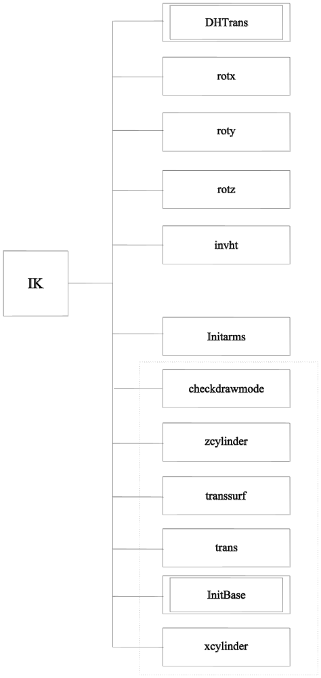

Fig. 34: Flow Chart for the MATLAB Function "IK"
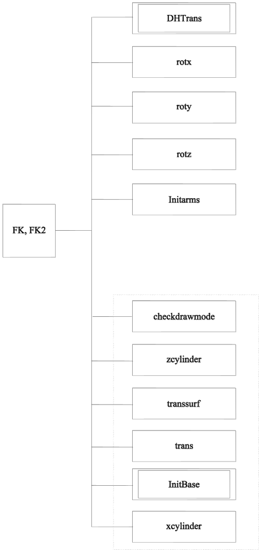

Fig. 35: Flow Chart for the MATLAB Functions "FK" and "FK2"

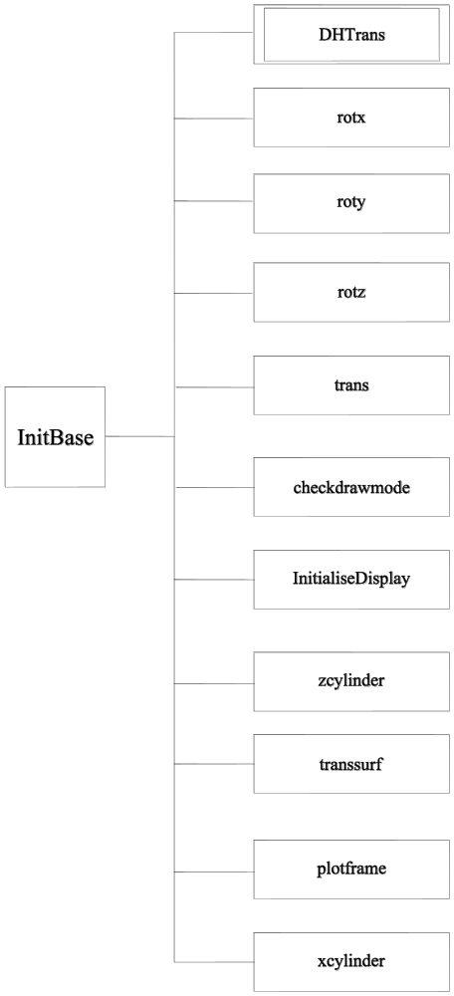

Fig. 36: Flow Chart for the MATLAB Function "Initbase"

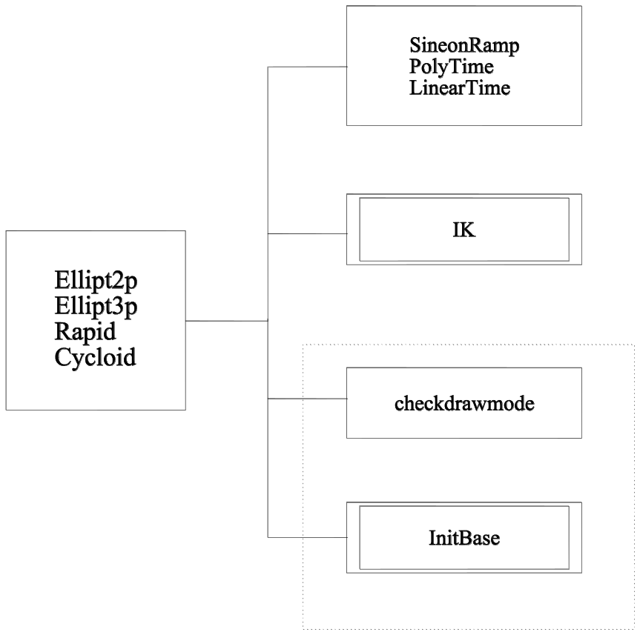

Fig 37: Flow Chart for the MATLAB Functions "Ellipt2p", "Ellipt3p", "Rapid" and "Cycloid"

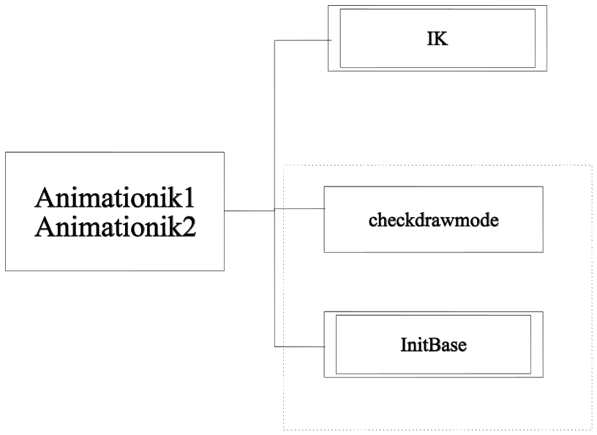

Fig 38: Flow Chart for the MATLAB Functions "Animationik1" and "Animationik2"

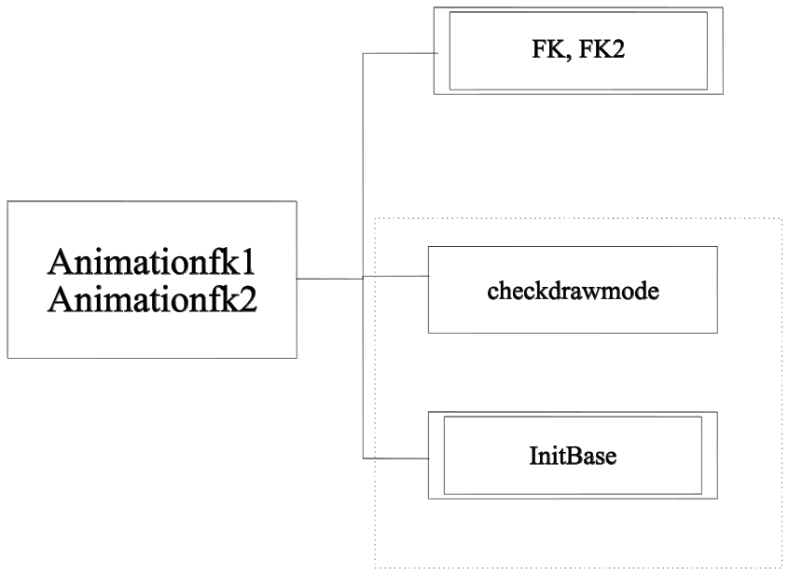

Fig. 39: Flow Chart for the MATLAB Functions "Animationfk1" and "Animationfk2"

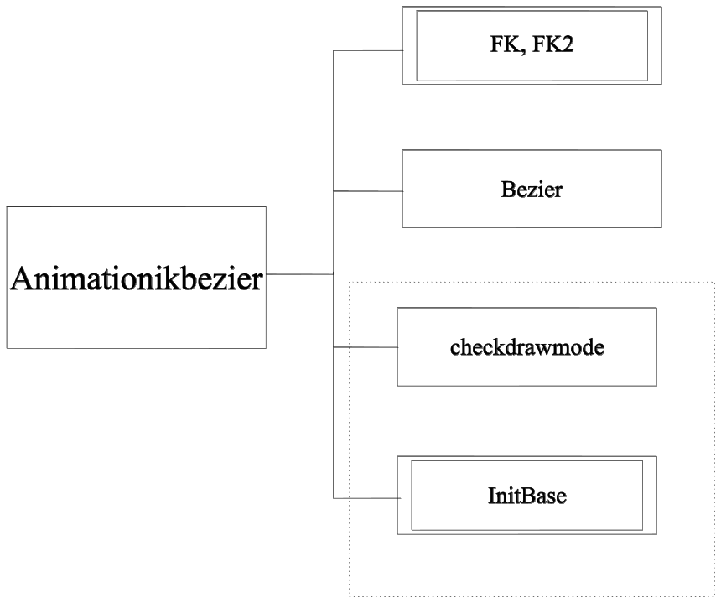

Fig 40: Flow Chart for the MATLAB Function "Animationikbezier"

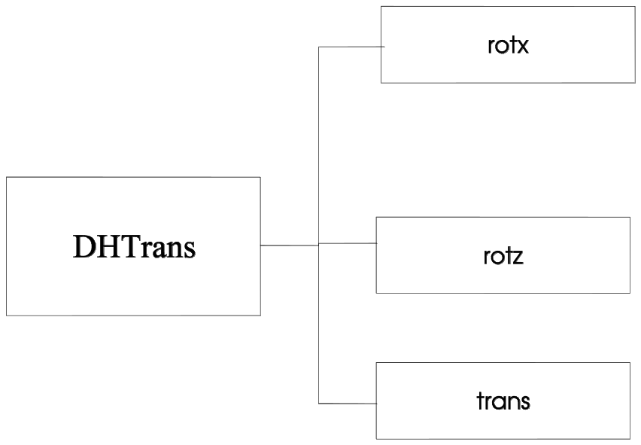

Fig. 41: Flow Chart for the MATLAB Function "DHTrans"

